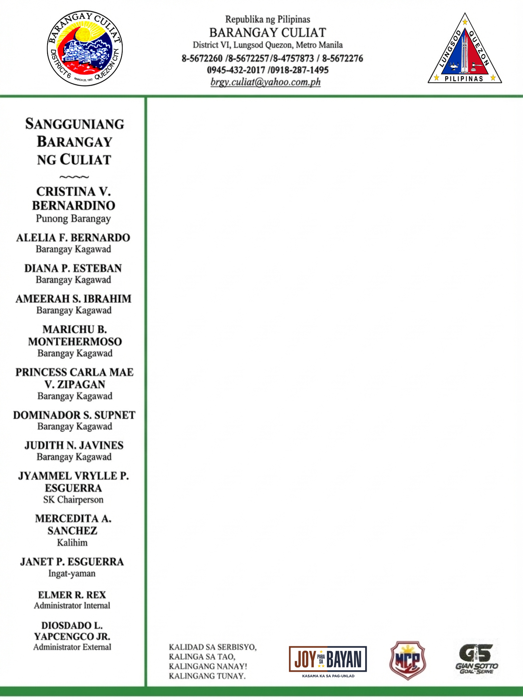

C E R T I F I C A T I O N

TO WHOM IT MAY CONCERN:

This is to certify that we interposed no objection to the liquor permit application of {full_name}, owner of {business_name}, located at {business_full_address}, CULIAT QC, as long as there is no violation of Quezon City Ordinance No. NC-85, S-89.

This further certify that:

- This business establishment is more than 50 meters from any academic school. (Sec. 15 Ord. 85)
- This business establishment is not erected on a public sidewalk, street, park or plaza in a government property.(Sec.17, Ord. 85)

- This business establishment is not a nuisance to public safety and order.

Given this {issue_date} at Barangay Culiat, District VI, Quezon City.



Control No : {control_number} SCAN TO VERIFY
"This document is online generated at www.barangayculiat.com and is valid without a dry seal. Its authenticity can be verified through the official website using the QR code or the Control Number provided."

